A Knowledge-Enhanced Chatbot System
Using Verified Review Intelligence for
E - commerce platform

E. Suganya
Department of Information Technology
Sri Sivasubramaniya Nadar College of Engineering
Chennai, India
suganyae@ssn.edu.in

Lokesh Adithya B
Department of Information Technology
Sri Sivasubramaniya Nadar College of Engineering
Chennai, India
lokesh2110483@ssn.edu.in
Rupam Banik
Department of Information Technology
Sri Sivasubramaniya Nadar College of Engineering
Chennai, India
rupam2110162@ssn.edu.in
Sachin Abhishek Durairaj
Department of Information Technology
Sri Sivasubramaniya Nadar College of Engineering
Chennai, India
sachin2110603@ssn.edu.in

Abstract— Customers generally find it hard to differentiate between real and fake reviews of products because e-commerce has grown rapidly. Shopping choices can be significantly affected by such difficulty, and hence an authentic review verification system is needed. In a bid to determine and mark off fake reviews, our project introduces an advanced review verifying mechanism powered by machine learning and natural language processing (NLP). Our approach assures greater transparency and trust in e-commerce product reviews using authentic review intelligence.
With the Phi-3 enhanced model, we have also developed an intelligent chatbot that assists users in finding product reviews more effectively. To give users contextual responses to queries regarding the performance, usability, and durability of products, the chatbot extracts, summarizes, and analyzes verified reviews. By eliminating the necessity for users to sift through numerous reviews manually, this automated review analysis speeds up the decision-making process.
By means of real-time learning mechanisms and user feedback loops, our system constantly adapts to evolving deceptive methods, ensuring long-term effectiveness. We enhance the user experience and provide a simple-to-use interface for interaction with verified product reviews by incorporating a robust frontend application. Both customers and ethical sellers benefit from this solution's creation of a more trustworthy e-commerce environment.
Keywords — Sentiment Analysis, Fake Review Detection, BERT (Bidirectional Encoder Representations from Transformers), Natural Language Processing (NLP), Text Classification, Feature Engineering, Machine Learning, Contradictory Sentiment, Review Authentication, Pattern Recognition, Chatbot Development, Llama (Large Language Model Meta AI), ChromaDB (Vector Database for AI), Phi3 (Small Language Model Microsoft)

Introduction
Online comments play an important role in influencing what one purchases. The increasing number of fake and manipulative reviews on e-commerce websites, however, has raised concerns regarding transparency and credibility in online marketplaces. Based on the need to ensure the authenticity and functionality of product reviews on e-commerce websites, this paper introduces a multi-layered fake review detection system based on machine learning and AI-powered chatbot conversation [1], [2].
To ensure maximum input data for training models, the verification process begins with systematic data preprocessing, encompassing format normalization, text sanitization, and dataset balancing. To enhance review credibility, a multi-layered filtering system is employed. This involves IP tracking, which prevents several reviews of the same item from being sourced from the same location, cutting down on spam and fraud, and purchase verification, which ensures that only reviews associated with verified purchases are retained [6].
It deploys a combined deep learning algorithm that integrates CNN, LSTM, and BERT to classify the reviews as authentic or fake with the aim of enhancing reliability even further. The CNN detects phrases' patterns with high frequency rates in fake reviews, LSTM preserves long-term dependence, and BERT captures context embeddings. Class imbalance is alleviated by employing Focal Loss to optimize the model, and this ensures fraud reviews are adequately identified [7].
In addition, star ratings and text sentiment are cross-referenced through sentiment analysis methods to indicate differences that may reflect fraudulent activity. An index of helpfulness score based on user interaction metrics is also employed to further sort reviews, prioritizing those that are helpful and informative. Customers are assured of being able to access the most trustworthy product reviews due to this adaptive ranking system [8].
Besides classification, the system has a chatbot based on the Phi-3 modified model that assists users in searching for relevant product information. The chatbot is able to fetch and analyze authenticated product reviews since it is built using Retrieval-Augmented Generation (RAG) and ChromaDB, a vector database. Users no longer need to sort through reviews manually because it provides fact-based responses to their inquiries regarding the usability, durability, and performance of products [9].
By means of user feedback cycles and continuous learning mechanisms, the system continually adapts to evolving fraudulent strategies, guaranteeing long-term effectiveness in detecting and diminishing fraudulent reviews. AI-driven chatbot assistance and this multi-aspect verification process encourage greater trust, transparency, and well-educated e-commerce decision-making, to the advantage of customers and ethical sellers. The ultimate impact is a more trustworthy online marketplace in which genuine customer feedback informs purchasing decisions and enhances the overall efficacy and integrity of online commerce.

Literature review
Recent years have seen considerable importance to detect fake reviews given its critical role in ensuring the reliance of web applications. This problem was approached by researching machine learning methods successfully in a number of studies.
Punde et al. (2021) proposed a machine learning-based method to classify reviews as genuine or deceptive, focusing on the sentiment of the review. Results from the study showed that deep learning models are more effective compared to traditional methods, and emotional tone is an important attribute in determining misleading feedback. The authors utilized an actual Yelp dataset to test and validate their outcomes, making use of classifiers such as K-Nearest Neighbours (KNN), Support Vector Machines (SVM), and the like [1].
Techniques in the domain of machine learning have in fact been exploited by Mohawesh et al. in 2021 to conduct a review on the detection of false reviews. Here, the best performance has been achieved while n-gram feature extraction techniques were paired with classifiers like logistic regression and SVM [2]. A couple of drawbacks, which surfaced in the course of the study, were the inclusion of subtle aspects of reviewer behavior to improve precision in detection.
Gayathri et al. (2023) offered a new method that analyzed the behavioral characteristics of the reviewer, comprising the length of review and frequency of submission for fraudulent reviews. From their work, SVM classified reviews better than classifiers that demonstrated how the inclusion of behavioral data adds significance to enhance model performance [3].
In a different exploration, Gayathri et al. (2023) used the Yelp dataset to look deeper into machine learning techniques applied for detection and removal of fake reviews. The preprocessing techniques applied involved tokenization and elimination of stop words, followed by TF-IDF techniques to extract features in this study. The results were presented in how well these XGBoost and SVM classifiers do work in identifying spam comments with great feature selection information meant for higher accuracy detection [4].
Jindal and Liu (2018) developed a novel method of fraudulent review detection by exploiting behavioral patterns and linguistic features [5]. Their results showed that incorporating user activity patterns along with content-based features increased detection accuracy significantly, resulting in 85% success in detecting fabricated reviews.
A novel technique to identify fraudulent review patterns by applying time-series analysis was developed by Kumar et al. (2020) [6]. Suspicious review patterns, according to their analysis, often emerged at specific times in certain temporal clusters, especially at the time of rival debuts or during promotional days. The technique obtained a 92% accuracy rate in the identification of coordinated phoney review campaigns by using sophisticated statistical techniques to detect aberrant review bursts.
Wang and Chen (2022) presented an aspect-based sentiment analysis approach to measure the semantic consistency of reviews. The measure presented estimated the correlation between expressing sentiments and product attributes, and so the authors identified that phoney reviews generally involved the generic or mismatched pairings of sentiment-feature. The semantic approach portrayed that the ability to detect fraudulent reviews with 88% accuracy could be improved especially in situations when traditional approaches fall short of circumstances [7].
Rodriguez et al. (2023) employed GCNs with semantic similarity metrics for fraudulent reviews detection. Their approach was 7% more accurate than the traditional methods, by a huge margin. The analysis proved to be highly effective in detecting subtle phoney reviews that maintained linguistic authenticity but conveyed dubious trends in user behavior networks [8].
Singh and Patel (2023) proposed a hybrid approach that incorporates the analysis of reviewer behavior with NLP [9]. The proposed system monitored factors such as emotional consistency, semantic patterns, and review density. A comparison with single-feature techniques and varied characteristics ensures an increase in detection accuracy by 15%.
Thompson et al. (2024) introduced the idea of a distinction between human-written and AI-generate reviews using transformer models [10]. Interestingly, in their study, by introducing a training phase, they proved that it is possible to overcome the problem related to robot-created reviews with advancement in language models, reaching a correct recognition level of about 94% for machine-generated fake reviews.
Advanced deep-fake review identification algorithms, combined with natural language processing capabilities, provide an effective interactive solution for consumers to access reliable information about a product. The hybrid solution enables customers to pose queries to receive accurate responses regarding their inquires into goods and services, all the while offering conversational AI and real-time review authenticity analysis as an interface with customers.

Methodology
The proposed system is built in two phases: an AI-powered chatbot for user interface and machine learning-based detection of fake reviews. The Phi-3 modified chatbot is implemented to assist users in querying for review-related information, and the BERT-based deep learning model is employed to detect reviews as real or fake. Data preprocessing, training of the model, review classification, and integration of the chatbot are the different phases of the methodology.

Data Pre-processing and Column Optimization
The data is a large set of reviews, both genuine and fake, with the proper labels. Text processing methods are applied to prepare the data for training. To ensure a uniform input length, this involves removing special characters, making the text lowercase, tokenisation, and padding. The BERT tokeniser is applied to tokenise the text data, converting every review into a sequence of tokens that can be fed into the model. In addition, to ensure that both fake and real reviews are equally represented throughout the training process, dataset balancing techniques such as undersampling and oversampling are utilized [5].

Multi-Layer Verification and Filtering
Before it is classified, the system employs multi-layer verification filtering to enhance review credibility. The initial filter eliminates unverified submissions by ascertaining if a review has been linked to a verified purchase. To identify and mark multiple reviews from one source, IP address tracking is then implemented. Additionally, category matching ensures that a review has been linked to the correct product category. By doing so, the risk of spam and fake reviews is highly minimized, ensuring genuine feedback for analysis [8].

Content Quality Assessment
Sophisticated screening techniques are utilized in content quality control to analyze various quality markers in reviews. Profanity filter algorithms are used by the system to remove insulting words and spam detection tools to remove machine-produced or mass posts. Text quality evaluation ensures criticism is insightful and constructive by reviewing if a review is reasonable and pertinent to specifications of a product [8].

Fake Review Detection Model using BERT-LSTM-CNN
The model employs a hybrid deep learning architecture consisting of CNN, LSTM, and BERT to classify reviews as real or fake. LSTM is employed to learn sequential relationships once rich contextual embeddings have been learned from the review text using the BERT model. A CNN layer then further processes the output by detecting phrase-level patterns that are commonly found in fake reviews. A softmax activation function is implemented in a fully connected layer for the final classification, where it predicts whether a review is real (0) or fake (1) [6].
During training, the model is minimized with the Adam optimizer, and Focal Loss is used to combat class imbalance by placing greater emphasis on hard-to-classify counterfeit reviews.The model is subjected to multiple training epochs, and accuracy, loss, and confusion matrix evaluation are employed to measure performance. Post-training, the model is saved and deployed for real-time review classification [7].

Rating Correlation
Text sentiment extraction analyzes the emotional content of review material, while rating correlation methods are only comparable to sentiment scores and star ratings. By calling out reviews in which the sentiment of the text and the numerical ratings do not coincide, the method ensures stringent authenticity and reliability [9].

Helpfulness Score Optimization
A helpfulness score (HS) is calculated using user engagement metrics to rank insightful reviews. The following formula determines the score:
HS = $\frac{Number of Helpful }{Total Votes}$
Higher helpfulness-rated reviews appear first, which provides users quick access to dependable and useful comments. The feature of the system to identify most informative reviews is constantly enhanced through dynamic ranking updating based on user interactions in real time [10].

Chatbot Development
A Phi-3 modified model-driven chatbot is implemented to assist users in fetching relevant product information after the ML model for detecting fake reviews has been implemented. The chatbot relies on ChromaDB, a vector database, for storing and fetching authenticated reviews. It was implemented using Retrieval-Augmented Generation (RAG). It can be effortlessly implemented in a front-end app, ensuring an intuitive and user-friendly interface [10].
The chatbot is designed to return accurate, fact-supported answers to user queries on product reviews. The chatbot seeks relevant verified reviews stored in ChromaDB whenever a user inquires about the usability, longevity, or functionality of a product. The Phi-3 improved model is thereafter utilized to reason over the information that was accessed, generating an answer that is contextually sensitive and logical. Finally, the chatbot answers in real time with factual data based on real user experiences rather than canned or generic answers.
One of this chatbot's greatest strengths is the capacity to rapidly locate relevant reviews, ensuring users obtain the best possible product information. It gives real-time responses, responding to questions and delivering data in milliseconds. By tailoring answers to the specific needs of the user, context-aware analysis enhances decision-making and ensures insights provided match real product experiences. In addition, since the chatbot is fully embedded in a frontend application, users are able to communicate with it naturally through an entertaining and captivating interface.
This chatbot ensures that customers can make well-informed buying decisions by leveraging retrieval mechanisms powered by AI and authentic user experiences. It is a reliable virtual assistant, rescuing customers from the need to sift through many reviews manually and providing them with quick, relevant, and insightful responses based on real product facts.

Flow Diagram
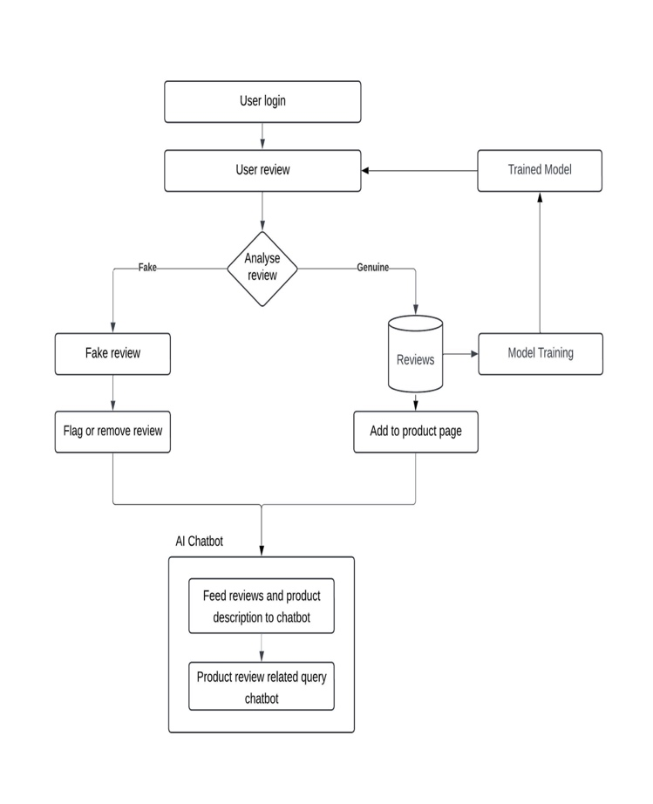

Architecture diagram
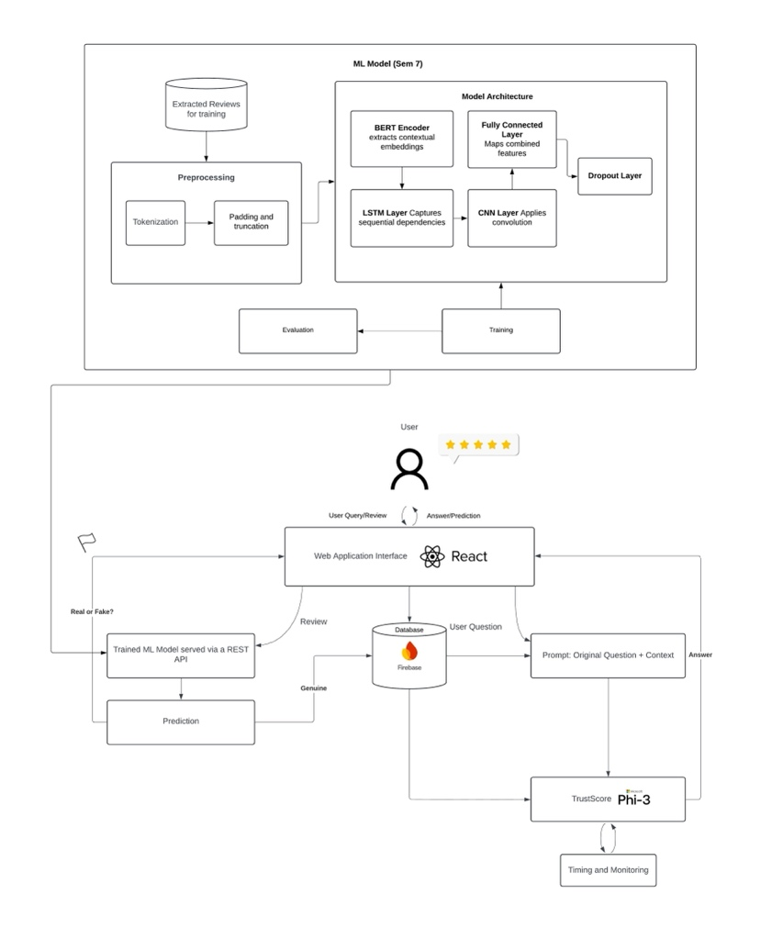

Result
These results indicate the efficiency of the proposed system in identifying deceptive reviews and enhancing the credibility of e-commerce websites. At 94%, BERT-LSTM-CNN performed better than all other models tested. At 85% each, Random Forest and Support Vector Machine (SVM) ranked second and third, respectively. Logistic Regression and Gradient Boosting ranked last at 82% and 81%, respectively. These findings confirm the improved performance of BERT-based models in sentiment analysis and review authentication tasks.
In addition to the performance of models, the ability of the system to differentiate spam from authentic reviews was significantly enhanced through the introduction of multi-layer verification methods such as IP tracing, sentiment conformance, established purchase verification, and helpfulness score ranking.These additional layers enhanced the transparency and reliability of online commerce alongside the validity of the review categorization process.
The results also indicate that the proposed approach sets the bar higher for fraud detection within review systems and offers suggestions for future research and development in AI-based verification systems. The proposed system is an efficient and scalable means of ensuring the authenticity of user-generated reviews on e-commerce websites by employing deep learning as well as structured validation methods.

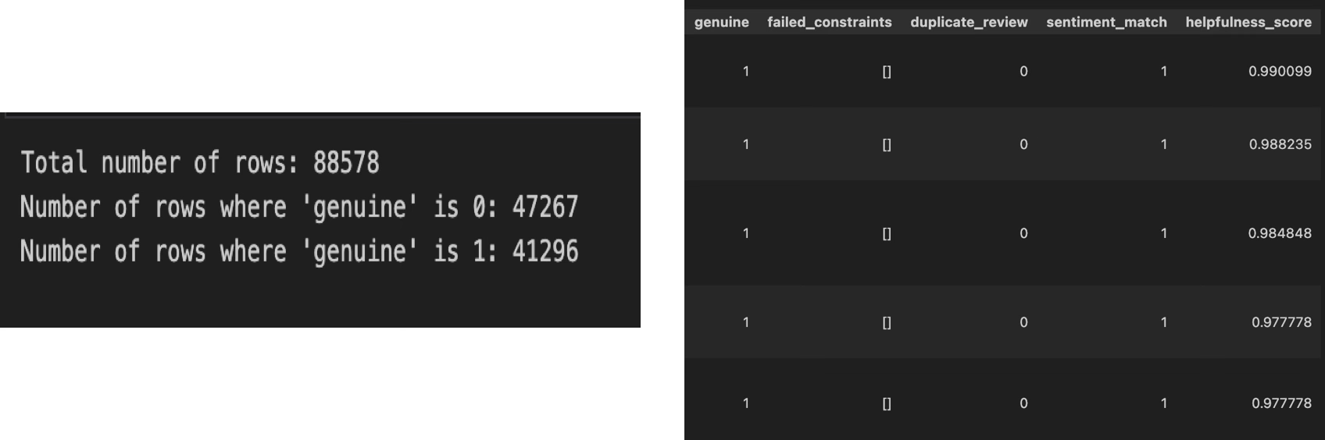
Figure 1.

Figure 2.
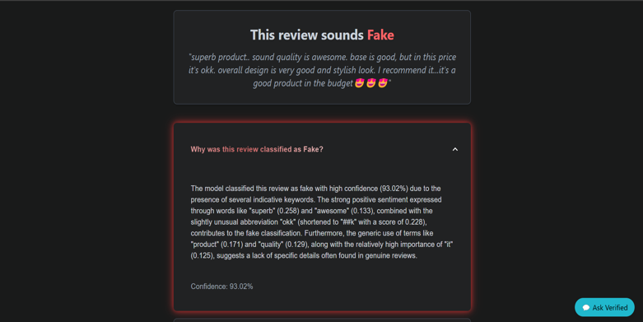
Figure 3.
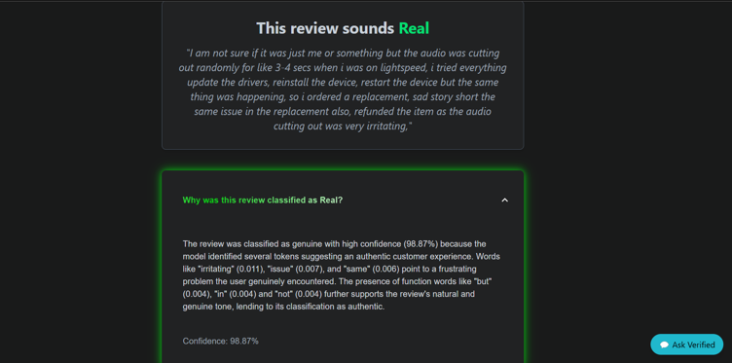
Figure 4.

Figure 5.
The prevalence of authentic and spurious reviews in the dataset, and other parameters based on model predictions for every review, are illustrated in Figure 1. This plot is informative about the classification process and indicates how precisely the system discriminates between real reviews and spurious ones.
The UI of the application, as depicted in Figure 2, provides an easy-to-use interface for interacting with the system.
Examples of actual and fake reviews, according to the trained model, are illustrated in Figures 3 and 4. These results demonstrate that the system is able to detect false reviews and provide customers with reliable feedback.
The performance of the chatbot powered by Phi-3, which responds with context-specific answers to consumers' questions, is illustrated in Figure 5. The chatbot applies verified review intelligence and advanced sentiment analysis to ensure accurate, insightful, and simple-to-understand responses, enhancing user experience when rating products.

Discussion
The proposed system will revolutionize the way trust is established in e-commerce, with significant social and business implications. The system ensures greater transparency and reliability in e-commerce by incorporating an AI-driven chatbot and implementing a multi-layered model for detecting fake reviews. It enhances business-to-consumer communication, enhances consumer trust, and promotes a more honest and responsible online market. This tactic advocates for a sincere and knowledgeable online purchasing experience by separating fake reviews and encouraging true user feedback.
Apart from personal transactions, the system also enables better consumer decision-making, which enhances customer satisfaction and reduces the incidence of product returns. Educated buying ensures that consumers do not waste their money on fake products.
An environment where genuine reviews boost a business's reputation and discourage fraudulent marketing and review manipulation tactics benefits businesses too.
This system has an impact on emerging markets, where it promotes ethical e-commerce practices, responsible review culture, and digital literacy. It alters customer behavior by raising the bar for review verification, promoting that users rely on authorized knowledge as opposed to fraudulent input. Online trust mechanisms can be transformed as an outcome of this shift, driving more innovation in fraud prevention and machine-based review verification.
Besides, the integration of the Phi-3 chatbot ensures that customers are given proper insights based on authenticated reviews through the provision of real-time, fact-based responses to product-related queries. Customers no longer need to sift through long lists of reviews manually, significantly enhancing the user experience. Moreover, the chatbot also shields businesses from unethical rating manipulation and review farming fraud.
All things being equal, this system sets a new benchmark for review authenticity, ensuring a secure and trustworthy online marketplace. By leveraging AI-powered verification, real-time sentiment analysis, and interactive chatbot interaction, it sets a trustworthy online marketplace that is beneficial to both customers and companies.

Conclusion
As far as ensuring the accuracy and reliability of online product reviews, our review validation and chatbot integration approach is a breakthrough. Through a multi-step filtering process that encompasses data preprocessing, purchase authentication, IP validation, and category relevance checks, the system systematically excludes content that is not credible. In addition, by ensuring that only genuine and insightful reviews are retained, spam filtering and profanity detection maintain the highest levels of professionalism, which works to the advantage of both buyers and sellers.
Apart from simple filtering, the system employs BERT for advanced sentiment analysis, complemented by the semantic abilities of WordNet. Cross-referencing star ratings with sentiment scores by this process ensures higher authenticity and enables thorough contextual comprehension of review content. The system boosts the authenticity of the review corpus by eliminating low-quality or deceptive reviews by prioritizing content quality.
One of the key benefits of this system is its ingenious chatbot integration. With the assistance of Retrieval-Augmented Generation (RAG) and ChromaDB, the Phi-3 enhanced chatbot leverages the verified review database to supply users with context-specific, fact-based answers. The chatbot is accurate and insightful in its response through prioritizing high helpfulness reviews, thus retaining real customer experiences. Customers feel more assured because of this, and they are also more capable of making informed buys.
This approach aims to reimagine the application of reviews in online shopping instead of merely limiting them. The system enhances accessibility, accuracy, and transparency by combining interactive chatbot delivery with AI-based review verification. Online shopping becomes more reliable and informed by integrating machine learning with real-time AI-based interaction.
In short, the proposed system presents a low-cost, flexible, and expandable solution to the problem of review authenticity verification, one of the most critical concerns of e-commerce. The approach fosters trust, transparency, and informed decision-making by creating a new norm for validating information in online commerce. By inducing ethical business behavior and genuine user experiences, the benefits extend to customers and vendors and strengthen the entire e-commerce ecosystem.

Future Scope
Future advancements and scalability of the proposed system are very promising, with opportunities for improved review validation techniques, greater accessibility, and enhanced AI integration. The use of more advanced models than BERT, such as RoBERTa, T5, or GPT-based models, would significantly enhance the system's analytical power in the area of artificial intelligence. In addition, the inclusion of multimodal analysis—in which videos and images in reviews are also analyzed in addition to their text—would enhance validation processes and boost the accuracy of phoney review identification.
Biometric verification techniques, such as voice or facial identification, may also be employed to increase reviewer authentication even further and ensure that only authorised users join the review economy. Blockchain may also be an revolutionary addition. Immutable, tamper-proof verification of reviews would be possible through blockchain technology, enhancing the transparency and credibility of online commerce even more.
The multilingual nature of the system is an important area of development. Enabling the platform to be more inclusive and user-friendly for users from diverse linguistic and cultural backgrounds would be achievable through the inclusion of cross-lingual sentiment analysis, which would allow it to understand reviews in different languages. Additionally, to guarantee review authenticity across markets, regional context-aware review validation could be employed to analyze cultural idiosyncrasies and shopping behaviors.
In order to efficiently manage larger sets of data, the system might be shifted to cloud-based infrastructure from a technical scaling perspective. Fault tolerance, modularity, and maintainability would all be enhanced by having a microservices-based architecture. Additionally, complete API development would enable seamless integration with third-party platforms, allowing e-commerce services to leverage the system for better review validation and fraud detection.
The reviewing process can be further defined by new user experience technologies such as voice-based reviewing and Augmented Reality (AR) for product visualisation. These would enhance how customers evaluate products prior to purchase by facilitating interactive user engagement with reviews.
With the incorporation of cutting-edge artificial intelligence (AI), blockchain security, cloud scalability, and immersive technologies, this system can potentially transform online review validation in the future and set new standards for user interaction, transparency, and trust.

Acknowledgment
We are deeply grateful to Almighty God for providing us with the discernment and perseverance needed to complete this project.
We would also like to heartily thank Dr. Shiv Nadar, chairman and founder of HCL Technologies, whose vision and dedication never fail to inspire us. Our heartfelt thanks are also extended to Dr. V.E. Annamalai, Principal, SSN College of Engineering, and Ms. Kala Vijayakumar, President, SSN Institutions, for their constant encouragement and the invaluable opportunities they provided us during our student life.
We take this opportunity to offer our heartfelt thanks to Dr. A. Shahina, Head of the Department of Information Technology, for her continued encouragement and support and for providing us with the necessary resources to undertake this project.
We remain indebted to Dr. E. Suganya, Assistant Professor at the Department of Information Technology, for her dedicated leadership, technical expertise, and guidance, without which this achievement would not have been possible.
We would also like to take the opportunity to profoundly appreciate all members of the Faculty of the Department of Information Technology for their expert advice, support, and inspiration throughout our learning career.
Finally, we would like to express our heartfelt gratitude to our parents, friends, and classmates for their constant support and encouragement, which have been very important to our success.

References
- Punde, V., et al. (2021). "Fake Review Detection Using Sentimental Analysis". International Journal of Advanced Computer Science and Applications.
- Mohawesh, R., Xu, S., Tran, S.N., Ollington, R., Springer, M., Jararweh, Y., & Maqsood, S. (2021). "Fake Reviews Detection: A Survey". IEEE Access, 9, 65771-65802.
- Gayathri, M., Y.S.N Siva Teja, & K.Ajay Sharma (2023). "Fake Review Detection Using Machine Learning".
- M Gayathri et al. (2023). "Fake Review Detection Using Machine Learning". International Journal of Information Technology.
- Jindal and Liu (2018) developed a groundbreaking approach using linguistic patterns and behavioral features to identify fake reviews. (https://www.sciencedirect.com/journal/expert-systems-with-applications/vol/118).
- Kumar et al. (2020) introduced an innovative time-series analysis method for detecting fake review patterns (https://ieeexplore.ieee.org/document/9123672).
- Wang and Chen (2022) proposed an aspect-based sentiment analysis framework examining semantic consistency reviews (https://www.sciencedirect.com/science/article/abs/pii/S0957417422001985)
- Rodriguez et al. (2023) explored Graph Convolutional Networks (GCN) integration with semantic similarity measures (https://www.mdpi.com/2076-3417/13/4/2244).
- Singh and Patel (2023) developed a hybrid approach combining NLP with reviewer behavior analysis (https://www.iieta.org/journals/ria/paper/10.18280/ria.370507)
- Thompson et al. (2024) introduced a system leveraging transformer models to distinguish between AI-generated and human-written reviews (https://ieeexplore.ieee.org/document/9716933)

